Big O notation describes how the runtime of an algorithm grows as the size of the input increases.

Algorithm | Best Case | Average Case | Worst Case

Linear Search | O(1) | O(n) | O(n)

Binary Search | O(1) | O(log n) | O(log n)

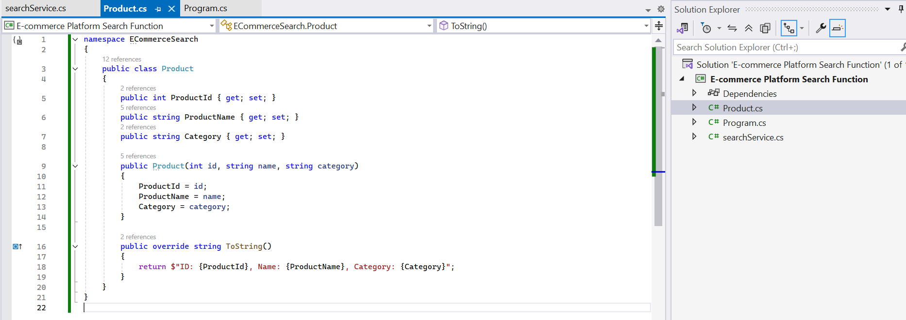

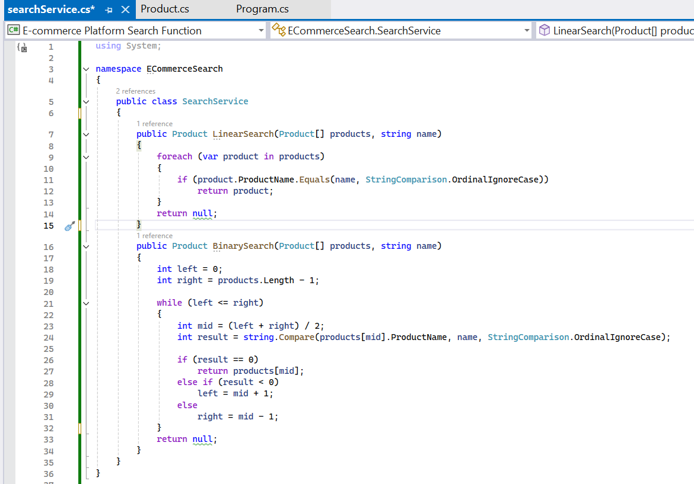

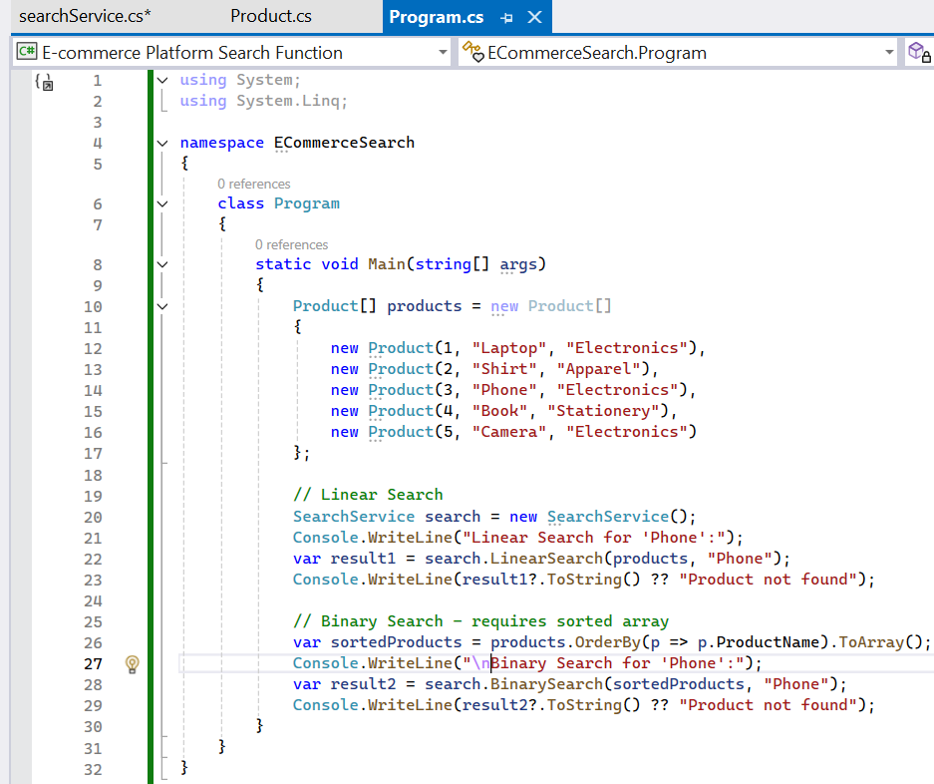

Algorithm | Time Complexity | Description
Linear Search | O(n) | Checks each element one by one
Binary Search | O(log n) | Efficient, but requires sorted data

Which to use:
Use Linear Search when:
The list is small or unsorted.
No time to sort initially.
Use Binary Search when:
You have large, sorted datasets.
You want fast lookup performance repeatedly.

Final Thoughts:
Binary Search is faster in large, sorted datasets.
But sorting has a cost too: O(n log n) initially.
For e-commerce platforms with millions of products, binary search or even better: indexing & search trees (like Trie, HashMap, or a database engine) is ideal.

